

GPA-80 & GPA-80HP ANTENNA

www.moonrakeronline.com

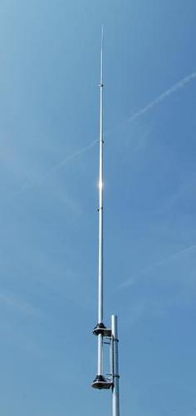
Specification

Frequency TX: 80-6m (3.5-57MHz) when used with an external ATU
Frequency RX: 2.0-90MHz
Power: 400W
Length: 6m approx.
Impedance: 50 Ohms
Socket: SO239
VSWR: 1:5:1 or better with an ATU

VSWR: Without a tuner depending on installation

80m (3.5MHz) 1.5:1 approx
40m (7.0MHz) 2.0:1 approx
30m (10 MHz) 1.5:1 approx
20m (14 MHz) 2.5:1 approx
17m (18 MHz) 3.5:1 approx
15m (21 MHz) 1.5:1 approx
12m (24 MHz) 3.5:1 approx
10m (28 MHz) 1.5:1 approx
6m (50 MHz) 3.5:1 approx
Instillation
Please insert each section of aluminium tube approx 10cm into each of the smaller sections and secure with the jubilee clips until all pieces are assembled – Please ensure that antenna is erected in free space for best results

